## GSE Honors Geometry Name ____________________

Georgia Milestone Review **Due Wednesday Nov. 28th**

Unit 1 – Transformations in the Coordinate Plane

 is plotted on a coordinate plane with vertices at , , and .

If  is the pre-image, identify the coordinates of each of the following images:

1.  2. Reflection across the *y*-axis
2. Reflection across the *x*-axis 4. Reflection across the line 
3. Rotation 90o clockwise about the origin 6. Rotation 90o counterclockwise about the origin
4. Rotation 180o clockwise about the origin 8. Dilation by a scale factor of 2
5. 

===============================================================================================

Unit 3 – Congruence and Proofs

1. One angle of a triangle measures 76o and another angle is one-fourth of the third angle.

Find the measure of each angle.

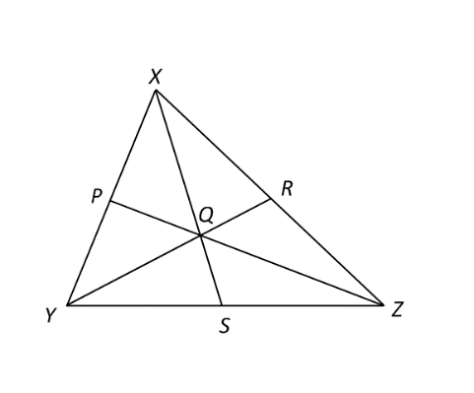

Point *Q* is the centroid of . Use the given information to find the value of *x*.

1.  12.  13. 

  

1. Given parallelogram *ABCD* with m and m, what is m?

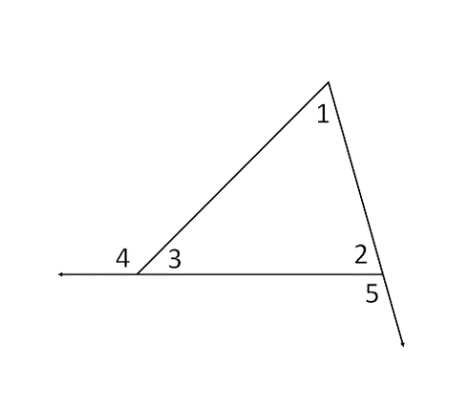

Use the figure to the right to answer each of the following:

1. Find m if m, m, and m
2. Find m if m, m, and m

Based on the given information about  and , determine whether or not the triangles are congruent. If so, identify the postulate that can be used to prove them congruent. If not, then write “not ”.

1. , , and 
2. , , and 
3.  and  are right angles, , and 
4. , , , and 
5. , , and 

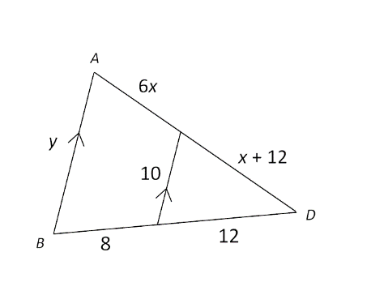================================================================================================

Unit 4 – Similarity

1. Find the perimeter of 

Unit 5 – Right Triangles

1. An equilateral triangle has an altitude of 36. Find the perimeter and the area of this triangle.
2. The diagonal of a square has length 80. Find the perimeter and the area of this square.
3. In ,  is the right angle, m, and . Solve the right triangle.
4. In ,  is the right angle, , and . Solve the right triangle.
5. Find the area of a regular hexagon with an apothem of length 15.
6. Find the area of a regular pentagon with side length of 8

===============================================================================================

Unit 6 – Circles

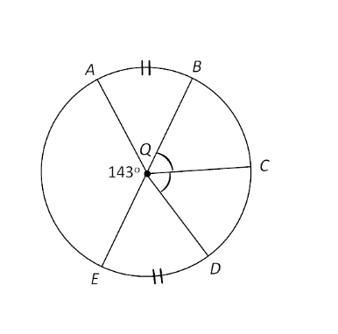

Find the measure of each of the following:

1. $\hat{CDA}$
2. .
3. 
4. A chord is 32 inches long and is 12 inches from the center of the circle. Find the radius.
5. Find the length of a chord that is 10 feet from the center of a circle with a radius of 26 feet.
6. You are standing 25 feet from the edge of a circular swimming pool. Your two lines of sight that form tangents

to the circle make an angle of 25o. What is the measure of the arc that is formed by these two lines of sight?

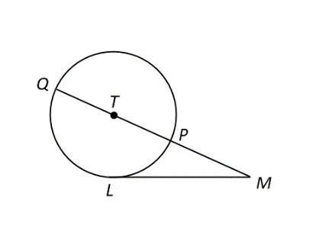

1. If *LM* = 45 and *PM* = 25, then what is the length of the diameter?
2. In OQ, m and . Find the length of $\hat{AB}$.
3. In OQ, m and the length of $\hat{AB}$ is 8. Find the radius of this circle.
4. OQhas a diameter of 12 and m. Find the area of the sector formed by , , and $\hat{AB}$.

===============================================================================================

Unit 7 – Surface Area and Volume

1. Find the surface area and volume of a right circular cylinder with radius of 8 and height of 18.
2. A right pyramid with height of 72 has a square base with side length of 130. Find its surface area and volume.
3. A sphere has a surface area of 112.89 cm2. Find its volume to the nearest hundredth.
4. A right circular cone has a height of  and a volume of . Find the radius of the base of this cone,

and then use it to find the surface area.

===============================================================================================

Unit 8 – Geometric and Algebraic Connections

1. Write the equation of the line that passes through the point  and is perpendicular to the line that passes through  and 

A triangle has vertices at , , and .

1. Find the equation of the midsegment that is parallel to 
2. Find the coordinates of the centroid
3. Graph the following circle: 

## GSE Honors Geometry Name ______________________________

Georgia Milestone Review **Due Wednesday Nov. 28th**

Unit 1 – Transformations in the Coordinate Plane

1. A’_________ B’_________ C’_________ 2. A’_________ B’_________ C’_________

3. A’_________ B’_________ C’_________ 4. A’________ B’_________ C’_________

5. A’_________ B’_________ C’_________ 6. A’_________ B’_________ C’_________

7. A’_________ B’_________ C’_________ 8. A’_________ B’_________ C’_________

9. A’_________ B’_________ C’_________

===============================================================================================

Unit 3 – Congruence and Proofs

10. 1st ___________ 2nd ____________ 11. x = ____________ 12. x = _____________

13. x = _____ 14. _____ = _____ 15. _____ = _____ 16. _____ = _____

17. 18. 19. 20. 21.

================================================================================================

Unit 4 – Similarity

22.

================================================================================================

Unit 5 – Right Triangles

23. Perimeter: _________ Area: __________ 24. Perimeter: _________ Area: __________

25. 26.

27. Area = ___________ 28. Area = ___________

===============================================================================================

Unit 6 – Circles

29.___________ 30. ____________ 31. ___________ 32. __________

33. ___________ 34. ____________ 35. ___________ 36. __________

37. ___________ 38. ____________

===============================================================================================

Unit 7 – Surface Area and Volume

39. SA = _____________________________ V = _______________________________

40. SA = _____________________________ V = _______________________________

41. V = _______________________________

42. r = _____________ SA = ____________________________

===============================================================================================

Unit 8 – Geometric and Algebraic Connections

43. 44. 45. ( , )

46.

